Annual Report
2015-16

EArtH Foundation

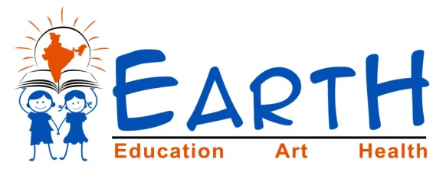
Introduction:
Our mission is to improve public education (government schools) in rural and backward India to achieve mass literacy in India. Strictly public education and strictly in rural areas. Our organization is built on a principle to make government schools the most preferred schooling for masses. As we know, masses in India are mostly poor who naturally can't afford private
schools. The overall goal is to make students, in government schools,complete, self-sustaining, and well qualified citizens to form a quality India.

Apart from 6 villages this year we adopted 1 more village.
EArtH Foundation’s adopted villages:
S.No | Village Name | District | State | Year of adoption
1 | Lambadipally | Karimnagar | Telangana | 2012
2 | Mutharam | Karimnagar | Telangana | 2013
3 | Peddarathupally | Karimnagar | Telangana | 2013
4 | Bhoopathipur | Karimnagar | Telangana | 2013
5 | Kalvasrirampur | Karimnagar | Telangana | 2014
6 | Garrepally | Karimnagar | Telangana | 2014
7 | Raghavapur | Nalgonda | Telangana | 2015
Earth Foundation’s appointed staff(Man power to village):
S.No | Village Name | Appointed
1 | Lambadipally | 2
2 | Mutharam | 2
3 | Peddarathupally | 3
4 | Bhoopathipur | 2
5 | Kalvasrirampur | 2
6 | Garrepally | 2
7 | Raghavapur | 2

EArtH Foundation’s specially designed Uniform distribution:
EArtH Foundation is done distribution uniforms, ties, belts, badges to all adopted school kids (7 villages).
We don't generally spend on 'material' things, but we felt giving these will help kids and also EArtH Foundation in achieving its goals, as explained below...
-Govt school uniforms are low quality. They don't last long.
-Helps in winning parents' hearts and their attention, helps in making them listen to EArtH Foundation, come to meetings/events (mobilization).
-Decent look gives confidence.
On the occasion of Independence day, EF distributed specially designed uniforms to Garrepally Primary school children. The chief guest to this function was Sulthanabad mandal Circle Inspector Sri Tula Srinivas Rao garu. And Dr. Padma(Md) from Sai Sudha hospital. Inspector, Sarpanch, MPTC, ward members and parents also attended.
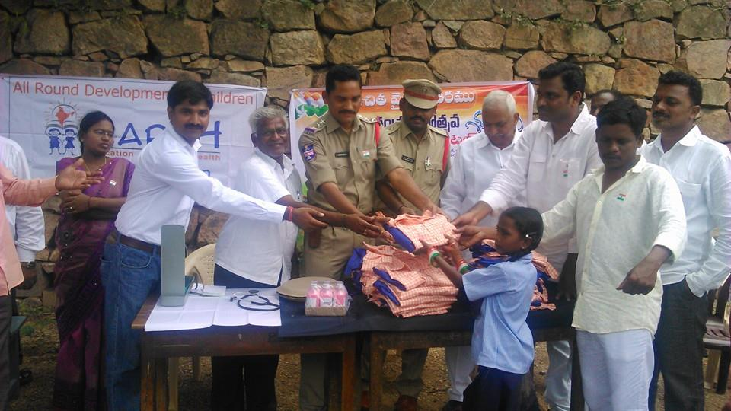 | 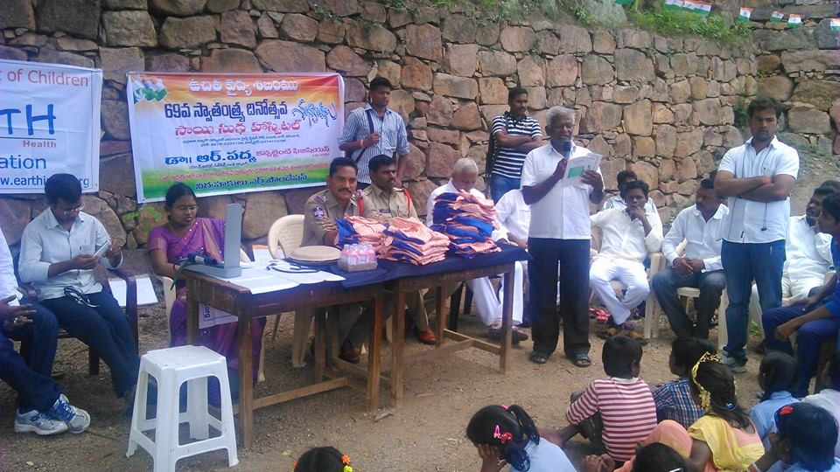

Uniform distribution in Mutharam: Great encouragement and speach by Mantani MLA, SRI PUTTA MADHUKAR GARU about foundation. Specially appreciated children performance. Children in EArtH Foundation's Uniform. More than 700 people attended this function.
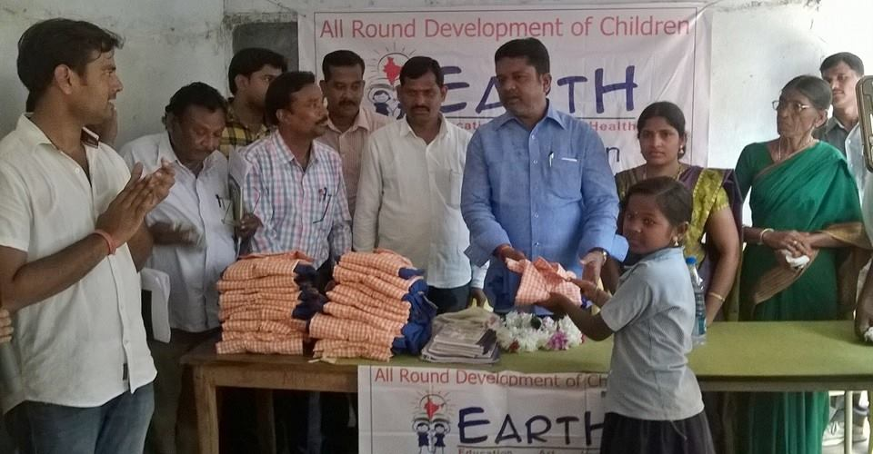 | 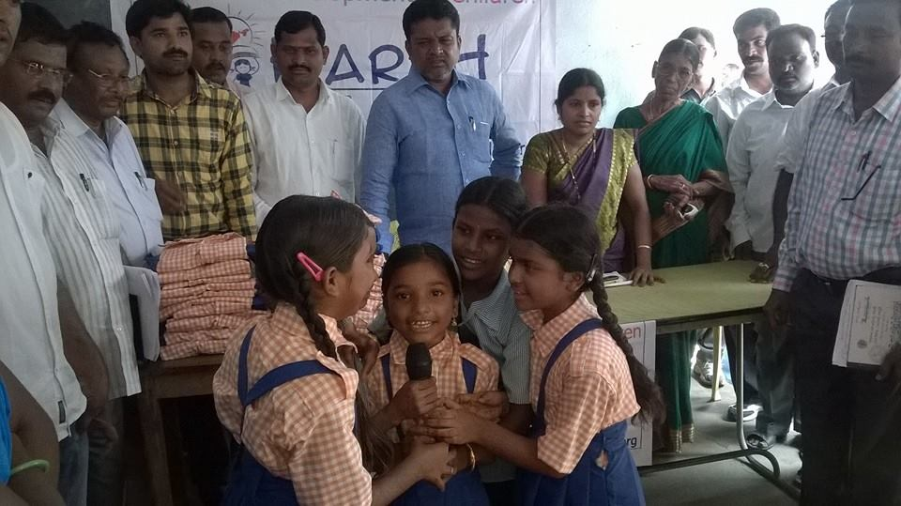

Uniform distribution in Peddaratupally village : Retired Deputy DEO Satyanarayana Rao distributed uniforms to all children. SARPANCH, MPTC, SUB SARPANCH, all ward members, parents attended this program.

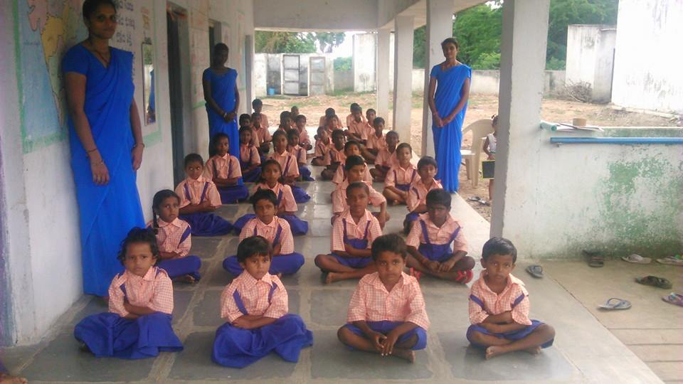 | 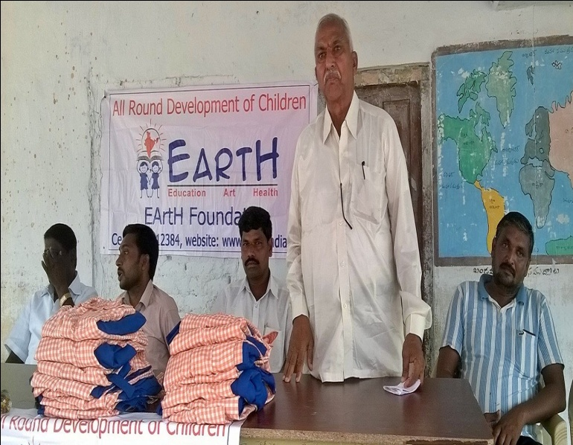

Uniform distribution in Kalvasrirampur sc colony Primary school :
Kalvasrirampur Sub Inspector Sri Lingareddy garu distributed EF'S special designed uniforms to children. ASI, SMC CHAIRMEN, PARENTS attended this program.
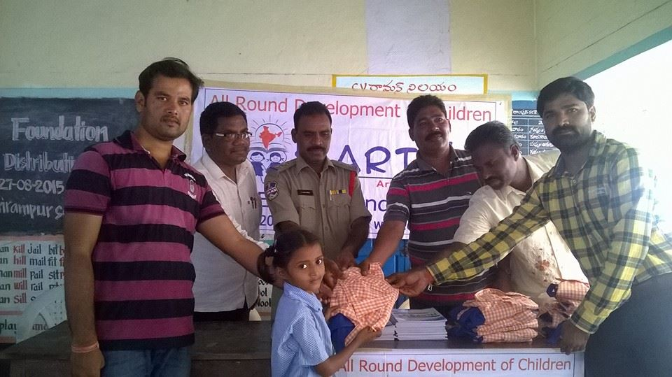 | 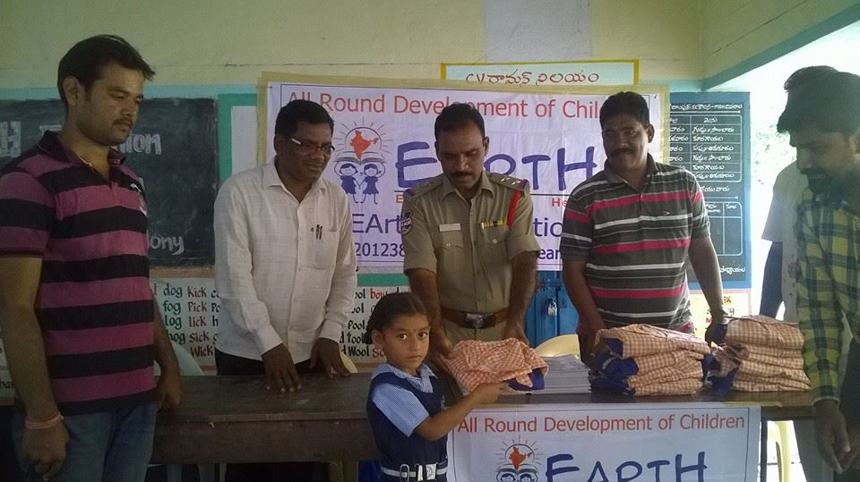

Press Coverage of "EArtH Foundation's uniform distribution and rally on Importance of Education"
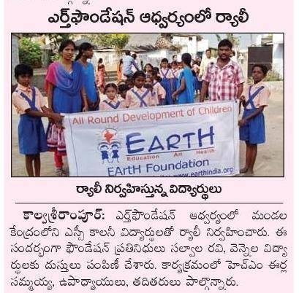 | 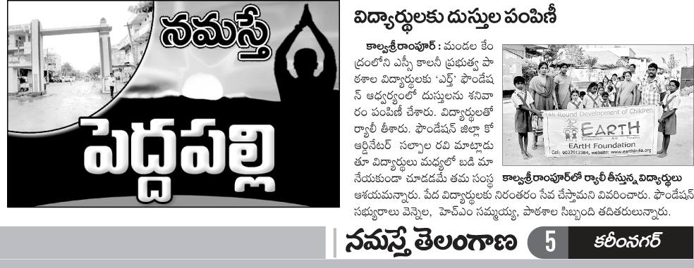

Earth Foundation’s Uniforms, Tie, Belt and Badges Distribution:
S.No | Village Name | To no.of Students
1 | Lambadipally | 34
2 | Mutharam | 82
3 | Peddarathupally | 52
4 | Bhoopathipur | 74
5 | Kalvasrirampur | 91
6 | Garrepally | 63
7 | Raghavapur | 90
Total Uniforms distributed till now |  | 486

PPTTC(Pre Primary Teacher Training Course) certificate course to EArtH Foundation's Staff:
In a part of capacity building, EF is providing PPTTC Course to our volunteers in association with Andhra Mahila Sabha. A certificate will be provided after successful completion of the course.
The things EF teachers learn from PPTTC....
-creative teaching skills - academics and skills.
-making students work on creative projects.
-art work with low-cost-no-cost material.
-How to identify and strengthen particular skills in each student that they are interested.
This is similar training that govt teachers get in DIET college.
Please see below photos for detailed information & TLM.
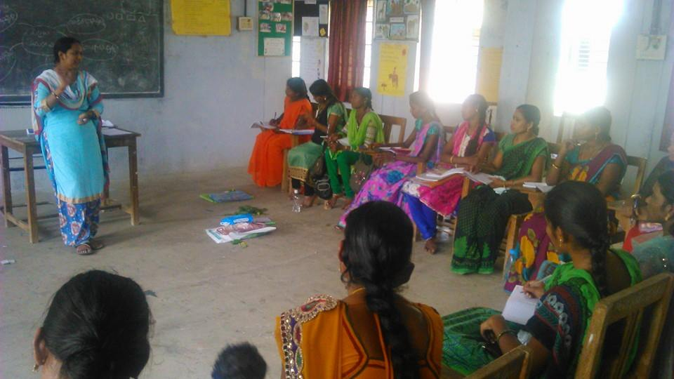 | 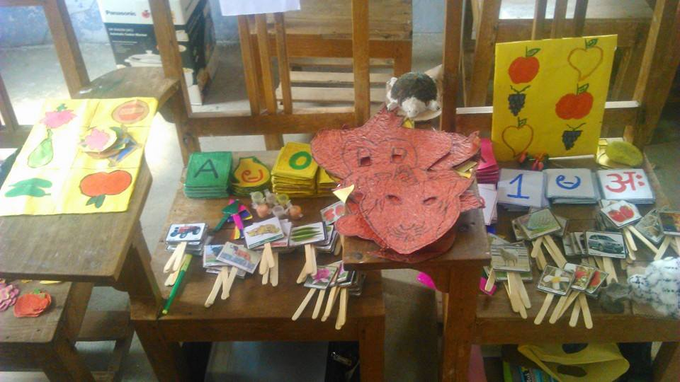

Impact of PPTTC(Pre Primary Teacher Training Course):
All of our EArtH Volunteers made number of Teaching Learning Materials for the children in the schools. Having inspired by that, now children are getting very creative and they are also making interesting objects.
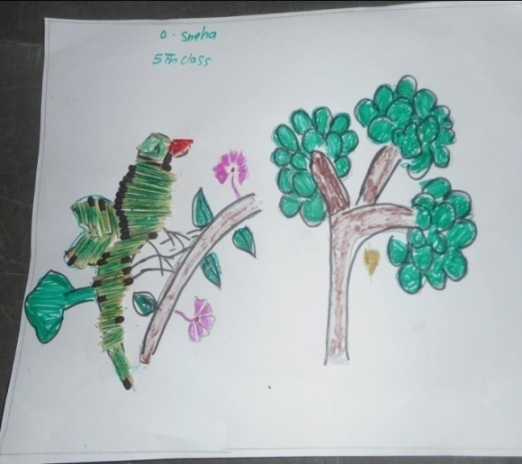 | 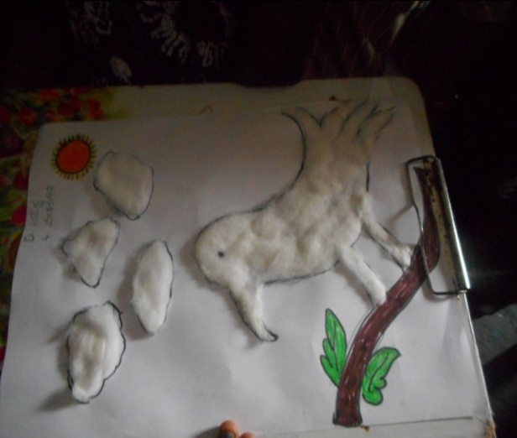
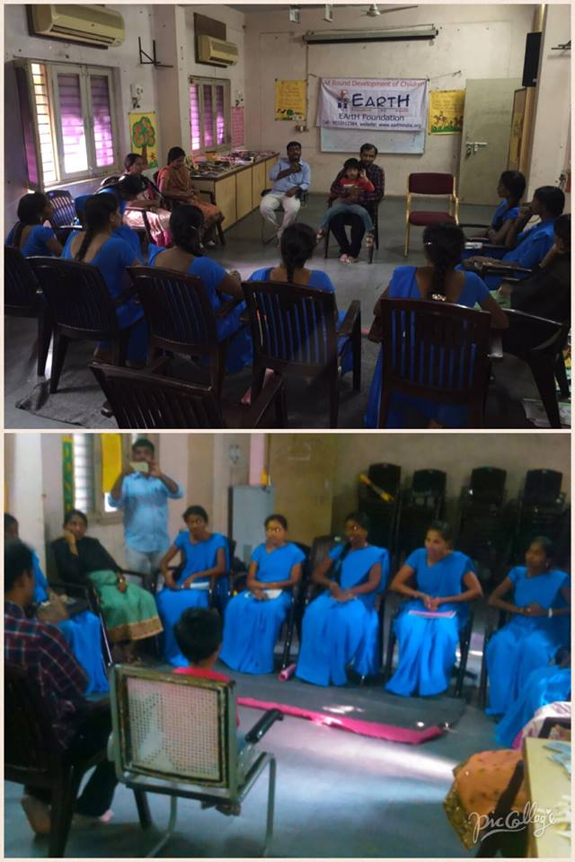 | 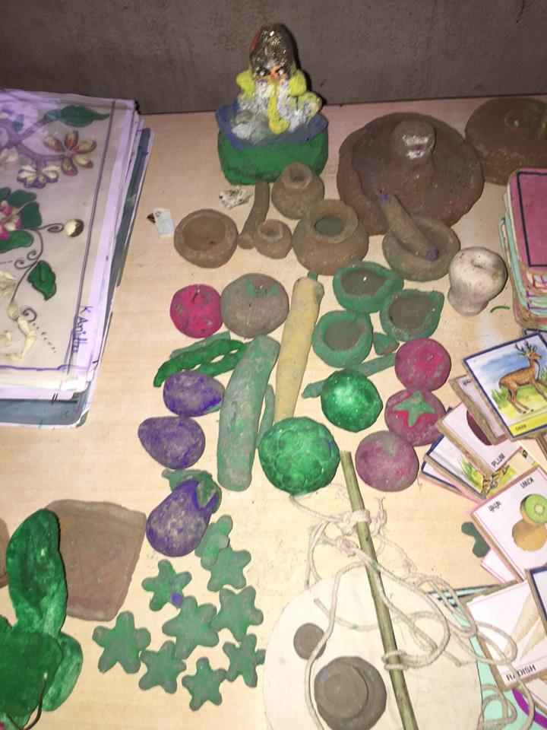

Mothers Awareness Program(MAP):
We are conducting awareness program for mothers on importance of education, arts and health. Agenda of MAP is to appreciate, inspire, encourage parents to take good care of their kids' studies and overall wellbeing :
Prizes for mothers (3 of 8 categories listed below):
"Mother of best student",
"Mother who attends most/all meetings conducted by School and Earth Foundation",
"Mother who cares most about their children's education at home (Helping in homework) and health" etc.
-And distributed Story books and worksheets to mothers to create reading habit in their children.
-Encouraged mothers to avoid TV serials, means more time for their kids.
-Children performed Songs, Rhymes, Poems and dances. This encourages their and other kids' mothers to recognize their kids' talent.
-We conducted 1 minute games for parents to make the meeting interesting.
-Prizes were distributed for games winners.
MOTHERS AWARENESS PROGRAM in Garrepally Primary School:
The main agenda is
"Children education and future ".Appreciated best student's mother
Appreciated the mother, who attended all meetings,distributed story books and worksheets to mothers, conducted fun activities.
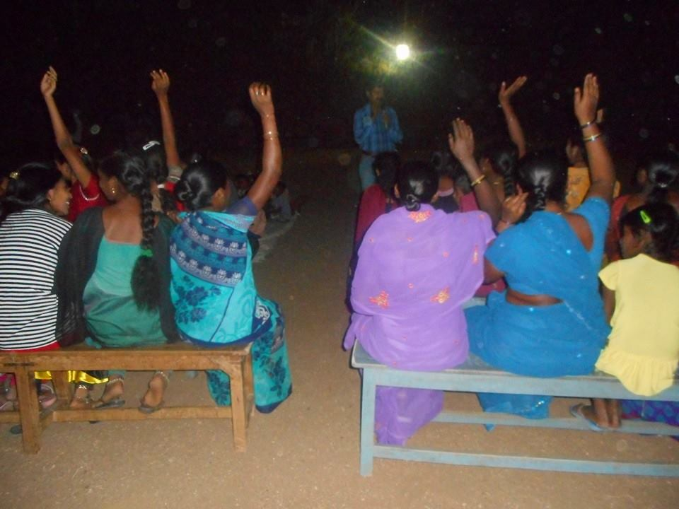 | 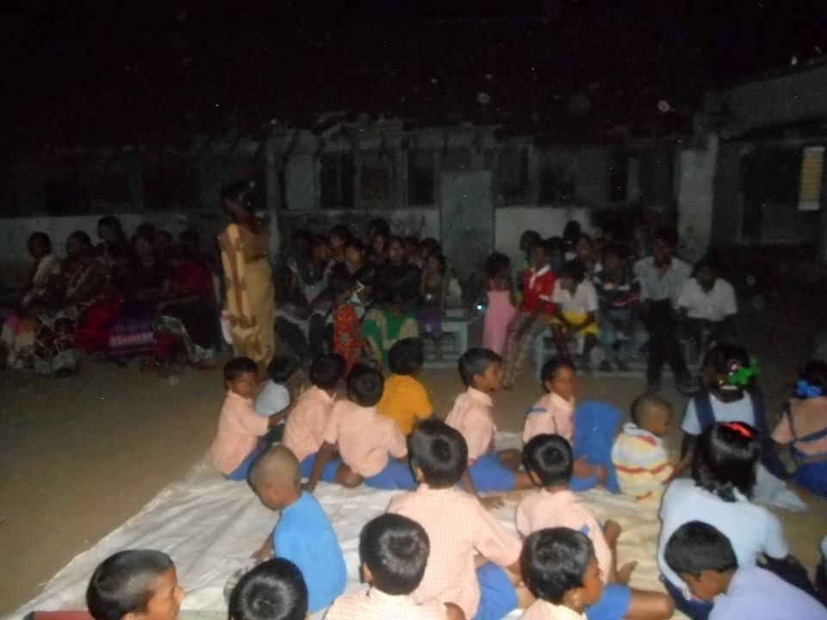

Mothers Awareness Program in Kalvasrirampur Primary School.
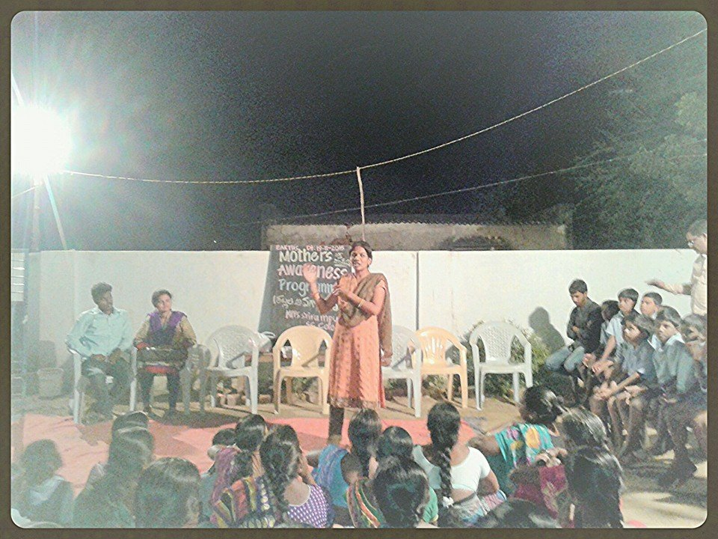 | 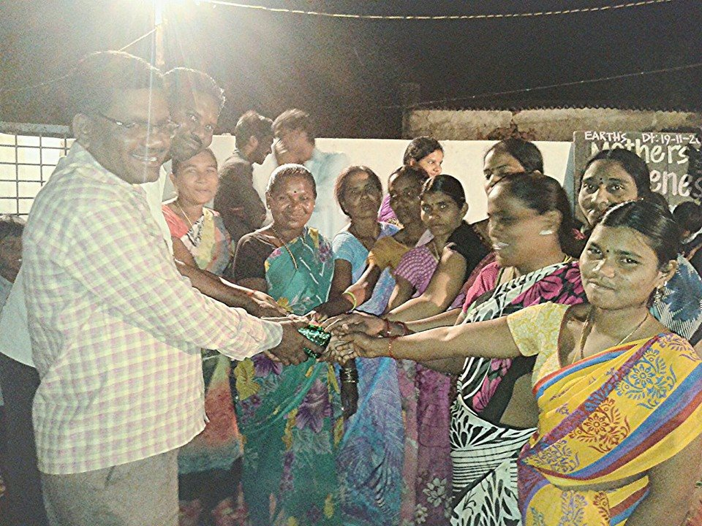

Mothers Awareness Program(MAP) in Mutharam:
Sarpanch(Well educated female) attended this program and gave inspirational speech to mothers. And school HM, Teachers, SMC chairman & members were also present.

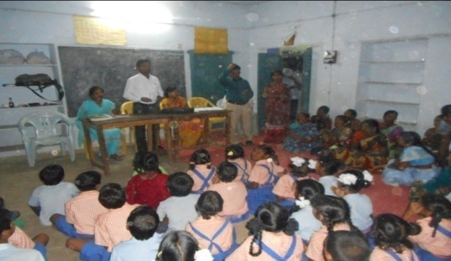 | 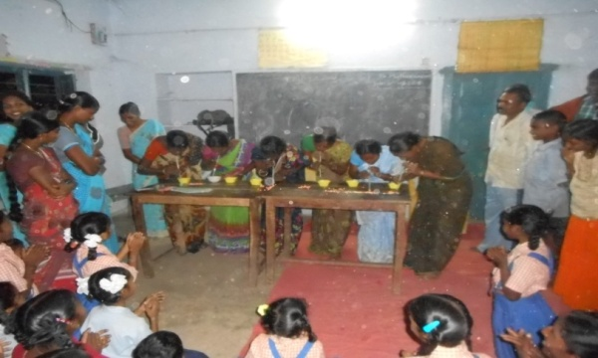
MAP(Mothers Awareness Program) in Raghavapur :
Sarpanch, ward members, youth
and parents participated in this program.
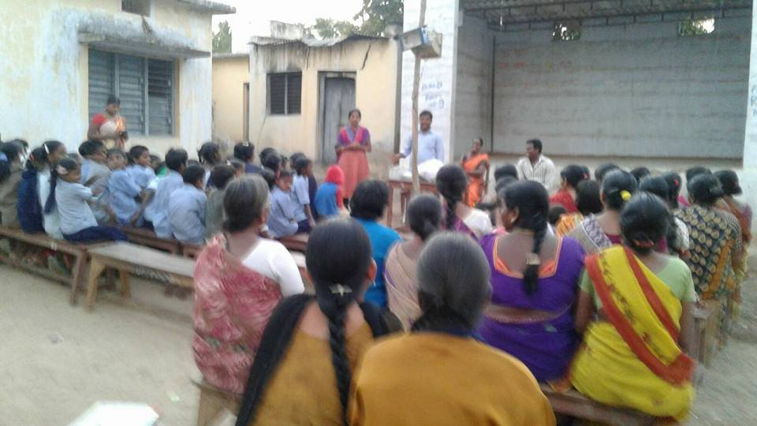 | 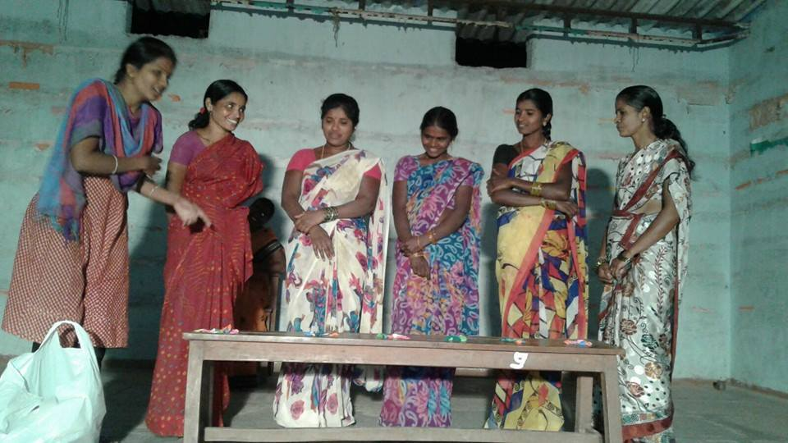

Organised various Health related activities in adopted village:
Health camp:
On the occasion of Independence day Earth Foundation conducted health camp in association with SAI SUDHA HOSPITAL -Karimnagar for Garrepally children and villagers.
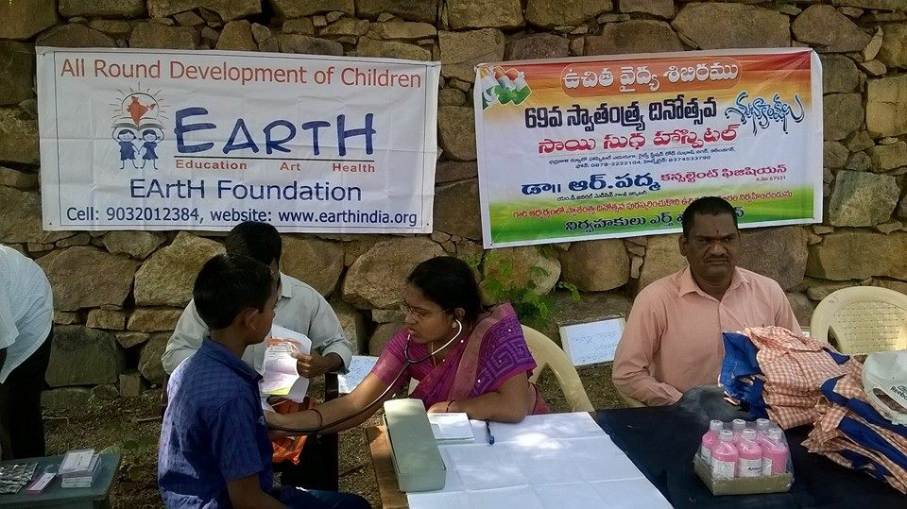 | 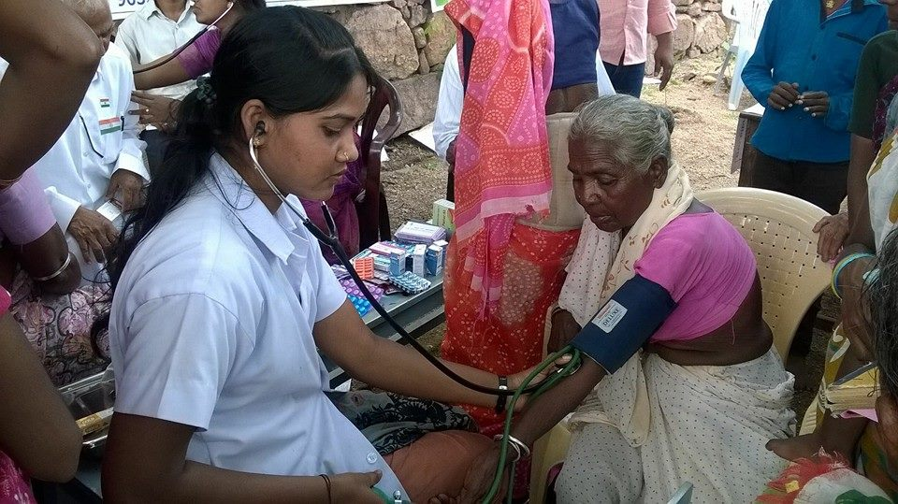

Health awareness campaign:
Conducted Rally in Garrepally village with primary school children.Main agenda is awareness on EDUCATION, NEATNESS &HEALTH.
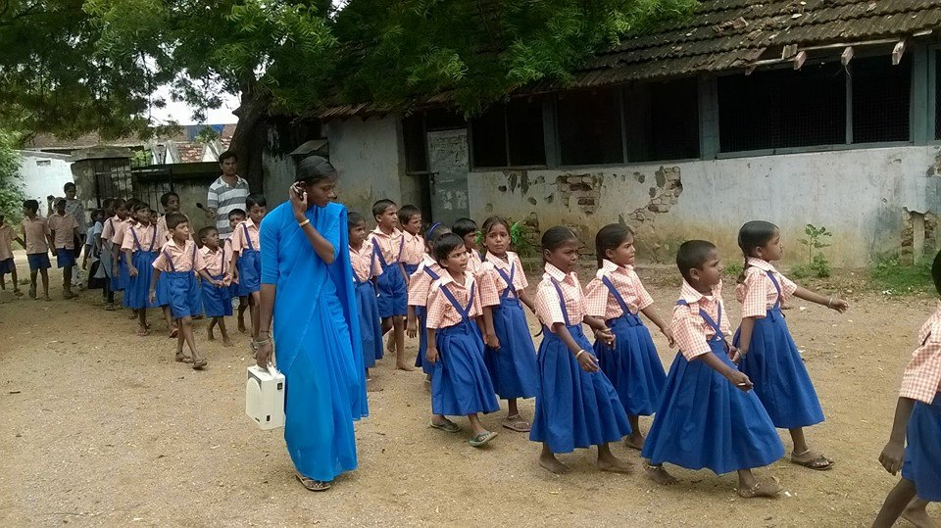 | 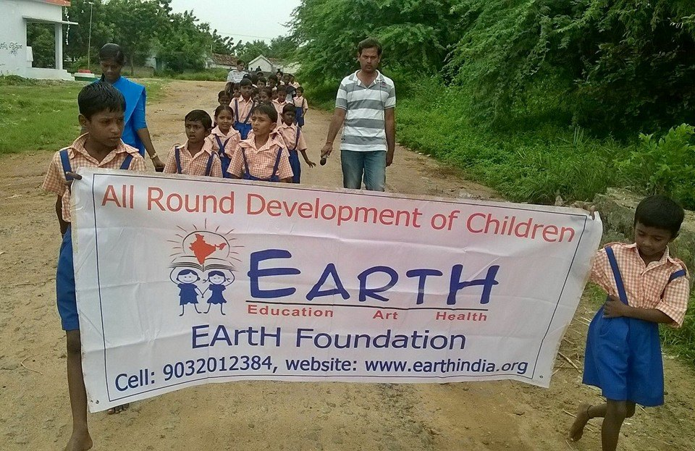

Importance of hand wash and awareness on preventing contaminating diseases:
Everyday HAND WASHING...These are the daily activities of EF adopted schools.
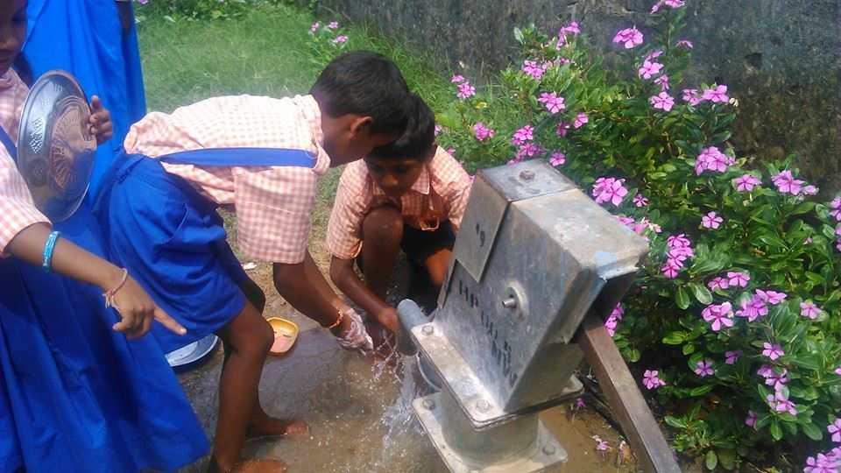 | 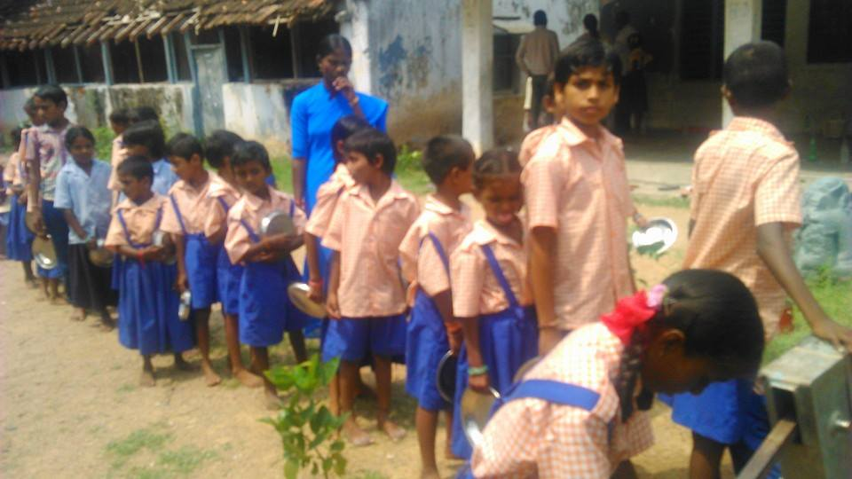

EArtH Foundation conducts adopted School Anniversary functions:
This was the biggest function of Earth Foundation. Children showed all round performance. Great practice and cultural activities. Nearly 500 people attended this function.
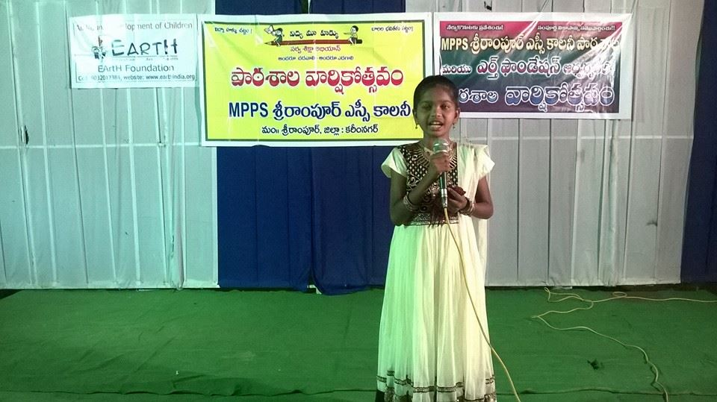 | 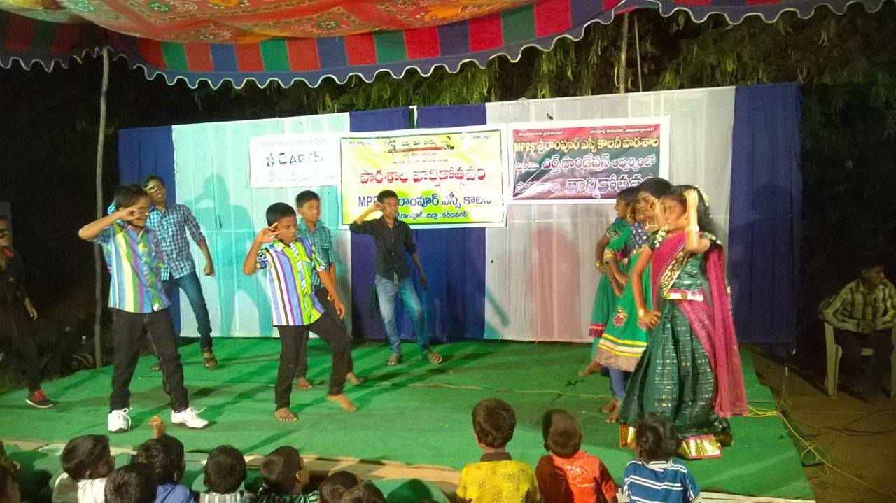
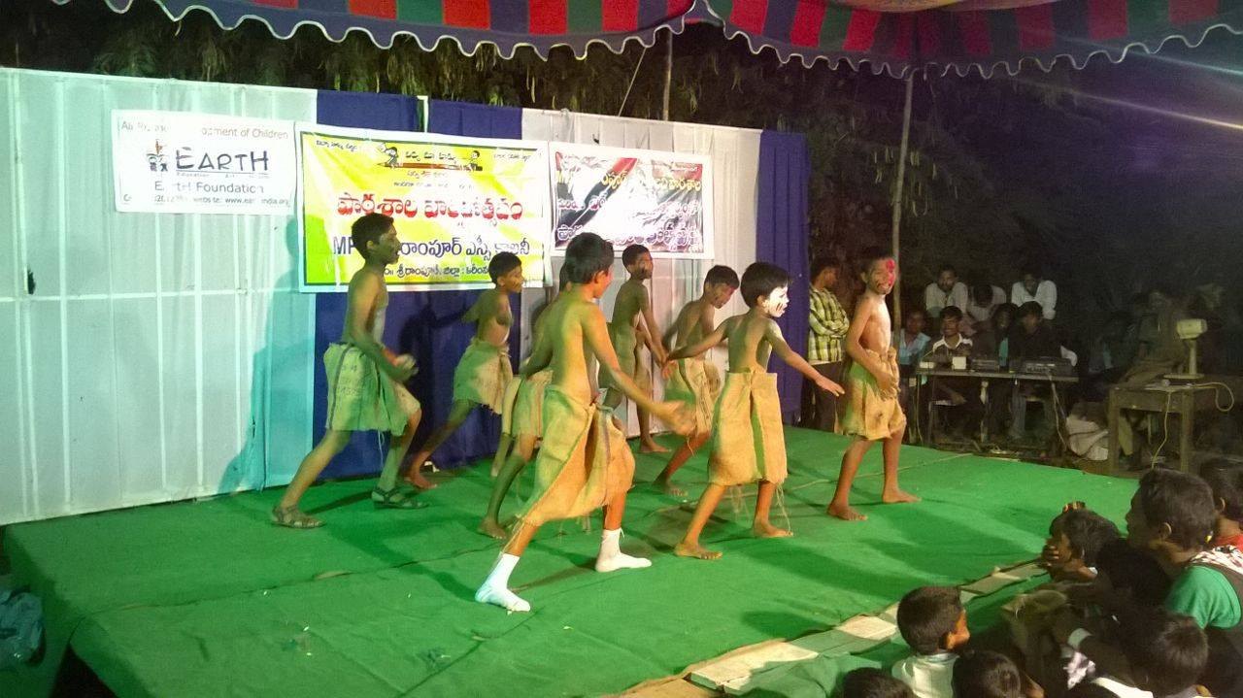 | 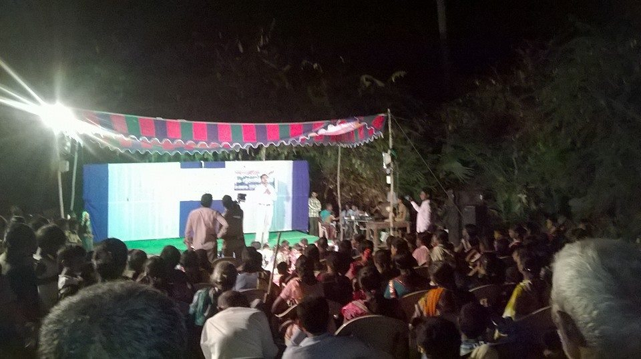

Press Coverage of EArtH Foundation's 3rd Anniversary function.
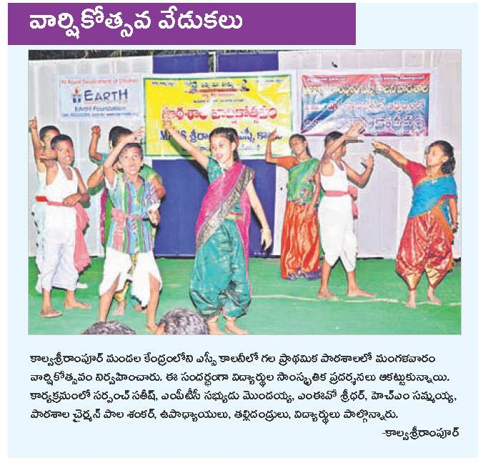 | 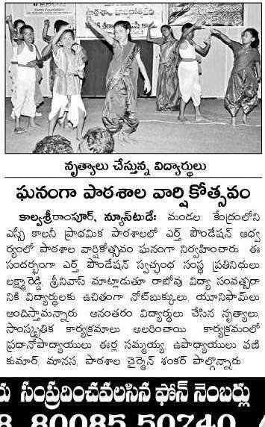

Various intellectual activities from the children:
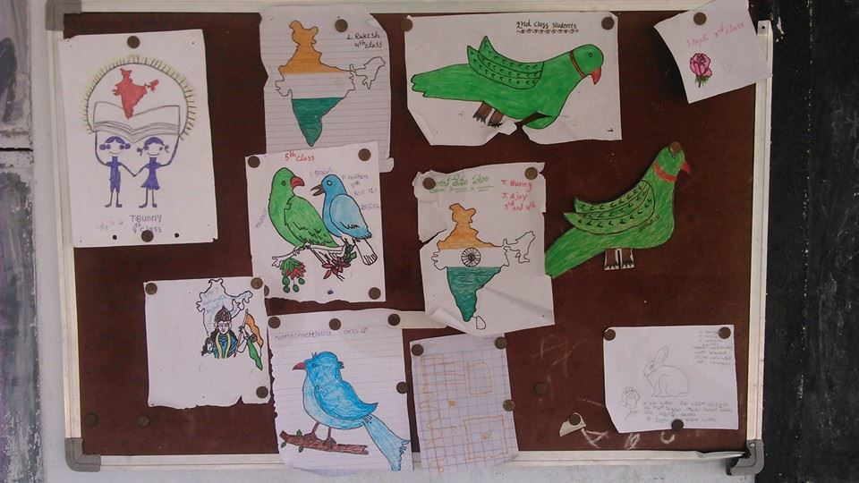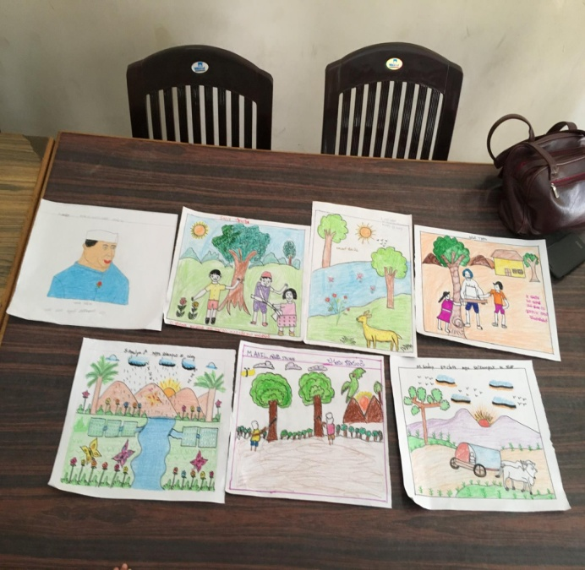
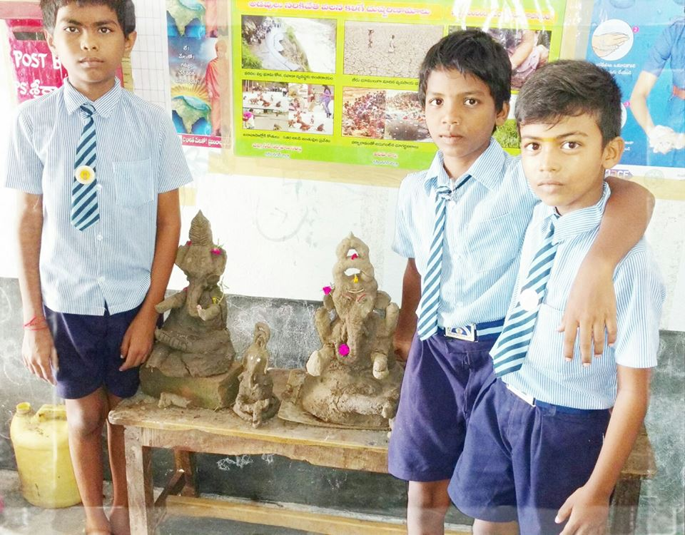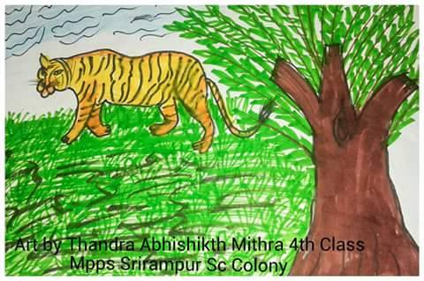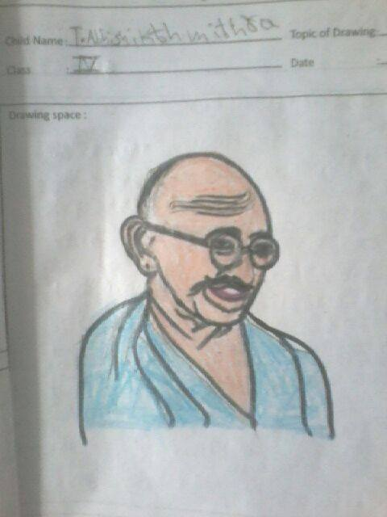
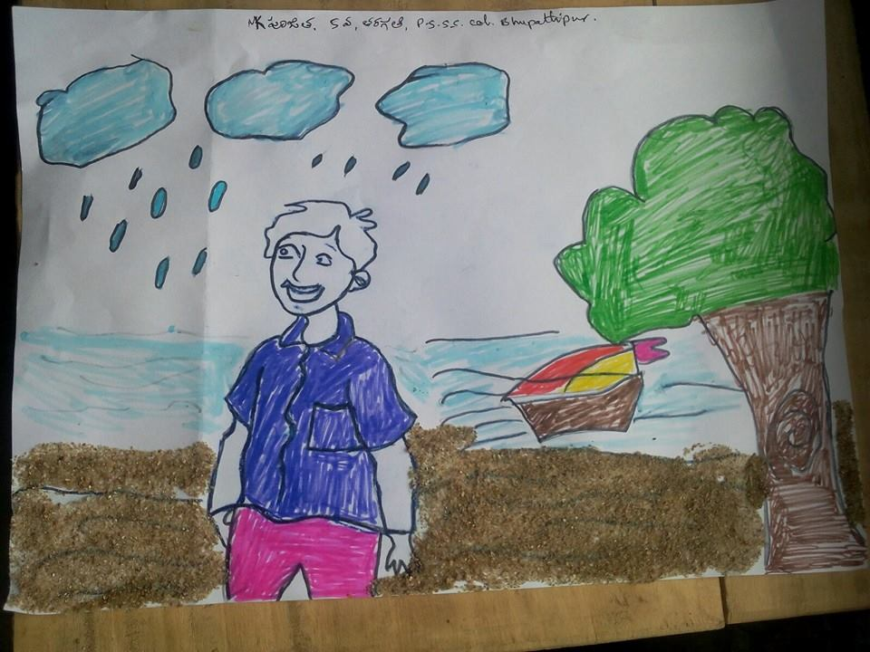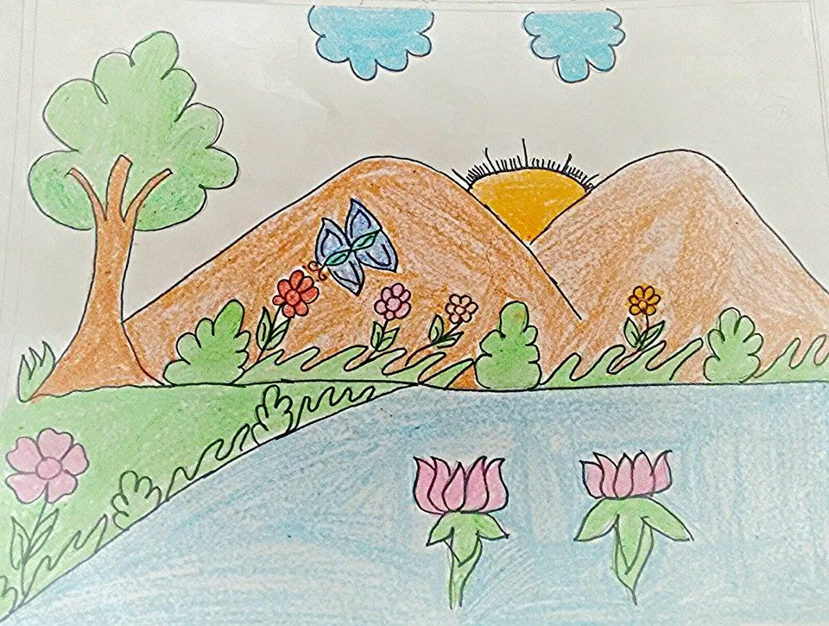
PRESS COVERAGE IN SOME OF THE FOUNDATION ACTIVITIES:
EArtH Foundation's article in EENADU SUNDAY MAGAZINE.
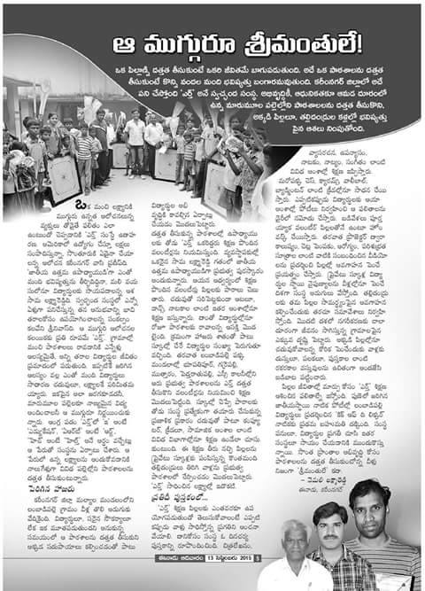

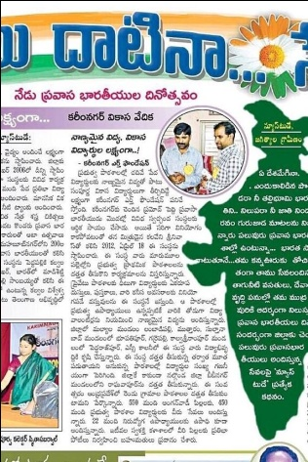 | 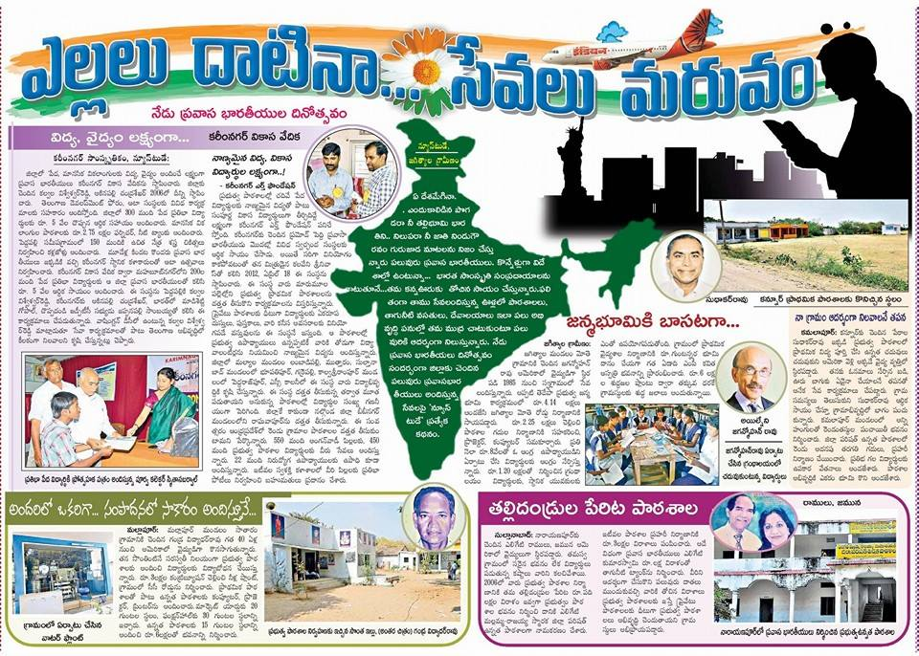

Good news! Our Earth Foundation's children (Kalvasrirampur SC colony Primary school) are selected for SOCIAL WELFARE SCHOOL. Congratulations to Raghavendra, Amulya and Anita.
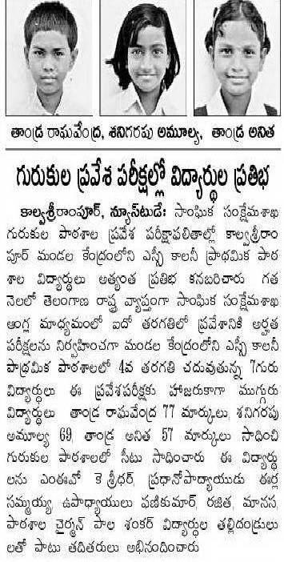 | 