Annual Report
2016-17

EArtH Foundation

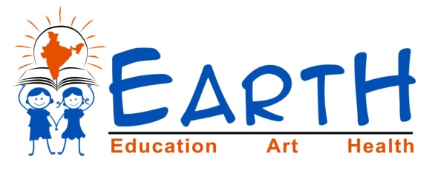
Introduction:
Our mission is to improve public education (government schools) in rural and backward India to achieve mass literacy in India. Strictly public education and strictly in rural areas. Our organization is built on a principle to make government schools the most preferred schooling for masses. As we know, masses in India are mostly poor who naturally can't afford private
schools. The overall goal is to make students, in government schools,complete, self-sustaining, and well qualified citizens to form a quality India.

Apart from 7 villages this year we adopted 2 more village.
EArtH Foundation’s adopted villages:
S.No | Village Name | District | State | Year of adoption
1 | Lambadipally | Karimnagar | Telangana | 2012
2 | Mutharam | Karimnagar | Telangana | 2013
3 | Peddarathupally | Karimnagar | Telangana | 2013
4 | Bhoopathipur | Karimnagar | Telangana | 2013
5 | Kalvasrirampur | Karimnagar | Telangana | 2014
6 | Garrepally | Karimnagar | Telangana | 2014
7 | Raghavapur | Nalgonda | Telangana | 2015
8 | CSPuram | Prakasham | Andhra Pradesh | 2016
9 | Malkapur | YadadriBhuvanagiri | Telangana | 2016

Earth Foundation’s appointed staff(Man power to village):
S.No | Village Name | Appointed
1 | Lambadipally | 2
2 | Mutharam | 2
3 | Peddarathupally | 3
4 | Bhoopathipur | 2
5 | Kalvasrirampur | 2
6 | Garrepally | 2
7 | Raghavapur | 2
8 | CSPuram | 2
9 | Malkapur | 3

93% increase in student enrollments in our adopted villages (excluding the 9th village which had 32% increase in just couple of months).

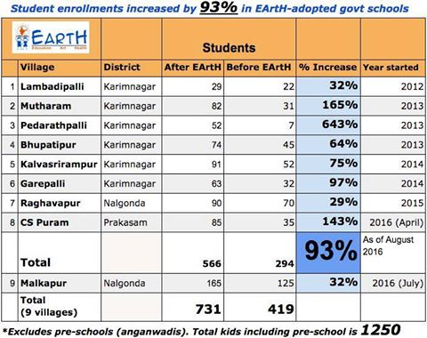

EArtH Foundation’s staff Training:

EF provides training to its teaching staff (Vidya Volunteers) 3 times per year for its new and old employees - to keep them up-to-date on their teaching skills and EF's methods and content.
We just finished a 3-day training for its staff of 6 villages. Training for other 3 villages is already done earlier this year. Training covers teaching all aspects in EF's work covering both goals, listing them here just to recap:
1) Bring all kids to school with permanent change (via awareness to villagers).
2) Provide personality developing education to kids.

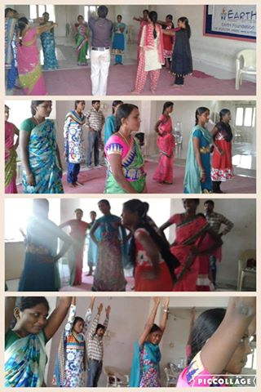 | 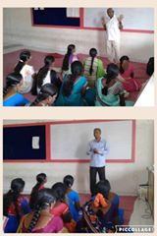

EArtH Foundation’s specially designed School Bags:
This year EArtH Foundation is giving school bags to its adopted kids, so far distributed to Kalvasrirampur kids. Thanks to Dasari Manohar garu for presenting bags to kids.
-Families in these villages are poor and can't afford bags.
-Bags make them a complete student (We already gave school uniforms, tie, belts and badges in the past).

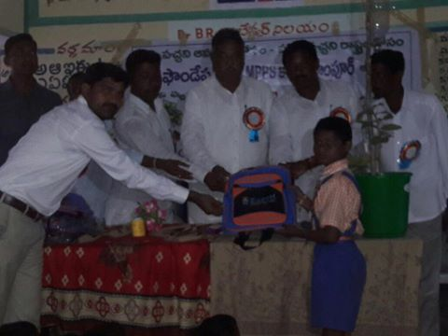 | 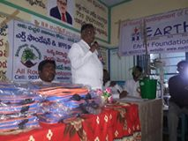
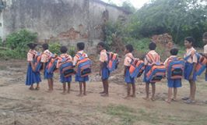 | 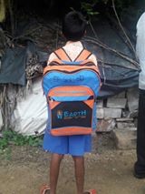
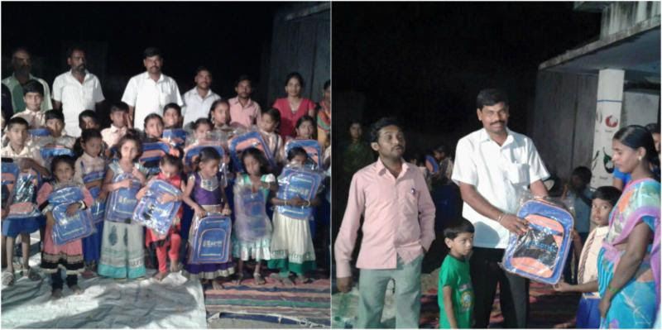

Earth Foundation’s School bags Distribution:
S.No | Village Name | Total no.of Students
1 | Lambadipally | 34
2 | Mutharam | 0
3 | Peddarathupally | 52
4 | Bhoopathipur | 74
5 | Kalvasrirampur | 91
6 | Garrepally | 63
7 | Raghavapur | 90
8 | CSPuram | 85
9 | Malkapur | 0
Total School bags distributed till now |  | 489

School Painting- Making learning very easier:
EArtH Foundation is focusing on different strategies to reach children.
16 topics(6 pictures of each fruits, vegetables, flowers, birds, animals & solar system. respiratory system, digestive system, urinary system, heart, skeleton, Gunitalu and good manners etc) chosen for painting in each school.
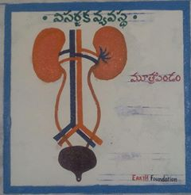 | 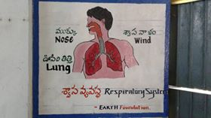
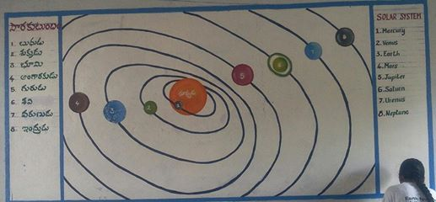

EArtH started giving Professional Training in Sports:

So far EF has provided sports kits to its adopted schools and provided basic exposure to indoor and outdoor sports, but without much professional training. We have recently hired a sports professional (PET) to improve on this. We will be providing professional training in sports, exercises, and yoga going forward.

We all know sports is useful aspect for every person and is preferable to learn this from early age. Lately, there has been reasonable importance for sports in Indian public (from Indian public response for 2016 Olympic medals), but sadly not enough encouragement and funding is coming from government sports bodies. We hope this will change and all Indian schools (public and private) will start providing exposure to sports.

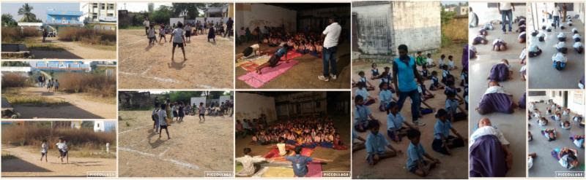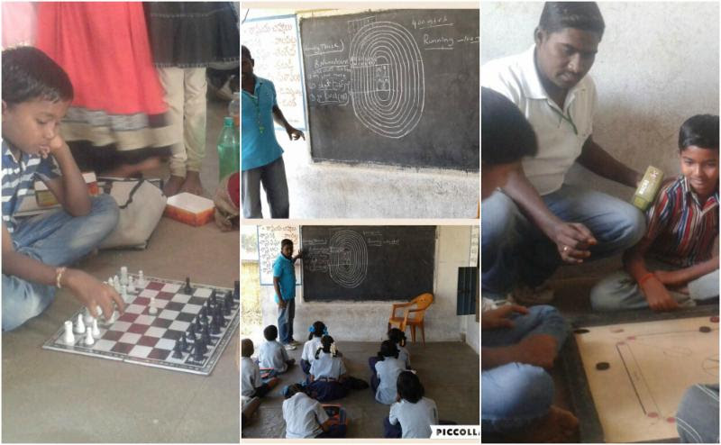

Conducted MAP (Mothers Awareness Program) in all 9 adopted villages:
MAP's objective is to mobilize parents to take good care of their kids' education and overall wellbeing. Highlighting some activities:
- Inspire parents to teach good daily habits to their kids such as reading, writing, homework (EArtH's worksheets)
- Prizes to parents who stand best in each category (in relation to their duties towards their kids). We have 8 categories.
- Make kids exhibit their skills in front of their parents (public speaking, singing, drawing). We think, this makes parents realize their kids' talent
- Encourage parents to attend other awareness meetings and speak out when they find something is not right in school or with the kids education. 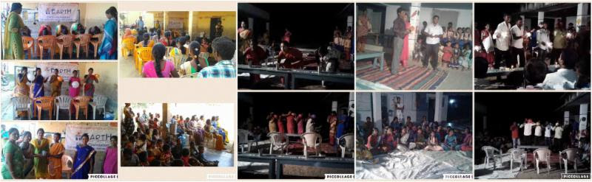

EArtH Foundation children in State & District level competitions:
EArtH Foundation kids(6 kids from 2 schools only)participated in STATE LEVEL COMPETITIONS called *Kriya Pillala Panduga* conducted in Kakinada. It's a huge event.
650 schools and 9000 contestants participated from Andhra Pradesh and Telangana.
Event Chief guests were -Dr. Japrakash Narayan, Actor Nagineedu(Maryada Ramanna movie fame), more.
1st Prize in Group Dance....
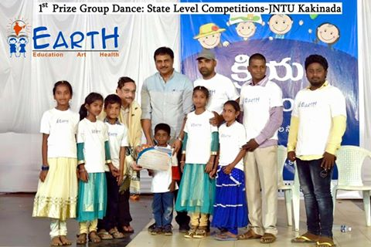 | 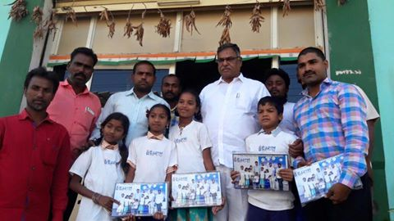

PARENTS AWARENESS CAMPAIGN:
To bring awareness on education and children's future, EF prepared PARENTS AWARENESS format. This format will help children to make READING & WRITING a HABIT at home, To know children status and set a goal, Maintain good HEALTHY HABITS5.
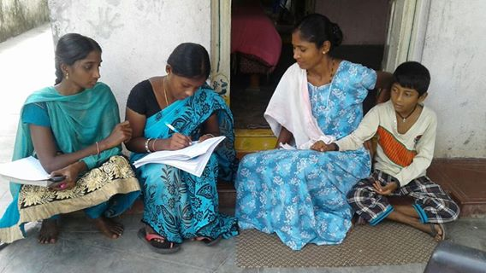 | 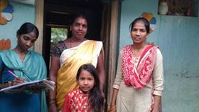
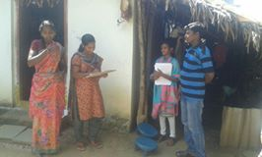 | 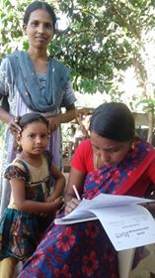

Awareness camp about 108
(AMBULANCE- Emergency services by government of AP & TELANGANA). in Bhoopatipur Primary school SC COLONY. This programme is mainly focuses on importance of AMBULANCE and it works

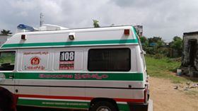 | 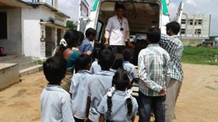

School infrastructure initiative by EArtH Foundation:
Still most of the schools, don't have proper facilities which are to be fulfilled by government.
EF team found and had taken Garrepally Primary school HM, Bhoopatipur Primary school SC COLONY HM & SMC CHAIRMAN to meet MLA Sri DASARI MANOHAR REDDY garu and put request letters for class rooms for Garrepally and Compound wall for Bhoopatipur.
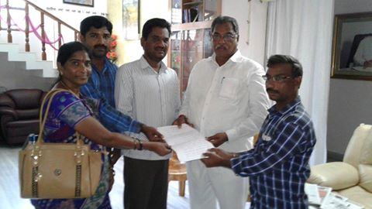

Awareness on Environment-"TWO plants for each KID"
Earth foundation is planting MOKKALU in each of its adopted villages - in school, houses, and on roads.
Two objectives:
1. Make our EF adopted villages greener
2. Make kids aware of environmental protection.
3. Imbibe CARE and RESPONSIBILITY in kids.
Each kid is responsible to maintain their 2 plants for their lifetime.
Earth does Inspection every 3 months to make sure plants are being maintained properly and give prizes to kids.
Thanks to Telangana and Andhra governments, they gave free plants to earth foundation (telangana gave as part of its HARITHA HARAM program).
We bought a drilling machine to quickly and easily make holes for planting 1000s of plants.
special thanks to our chief guest MLA Sri DASARI MANOHAR REDDY garu.
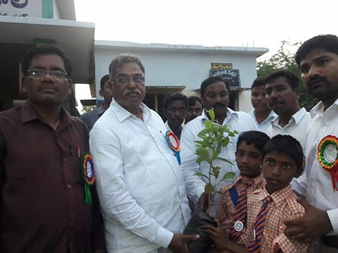 | 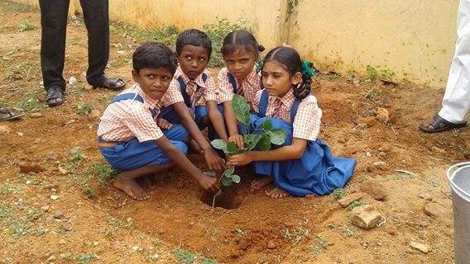
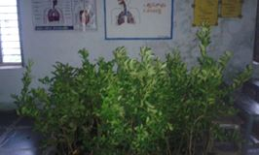 | 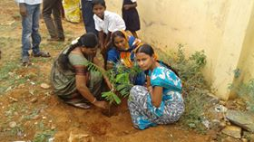

Government school annual day celebrations continues:
Primary school annual day functions. Again our chief guest was Peddapally MLA Sri DASARI MANOHAR REDDY garu. EF salutes him for his great encouragement and support. On this occasion, he PROMISED that he will complete the compound wall of the school.
Great practice and performance of children. These annual functions are another proof that EF is discovering and encouraging students' talent. Sarpanch, ward members, local leaders and nearly 400 villagers participated in this program. Thanks to HM and SMC CHAIRMAN for successful program.

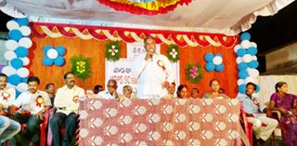 | 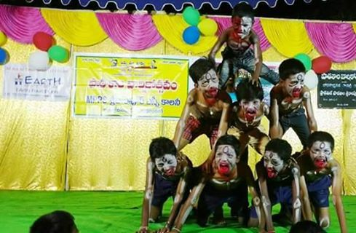
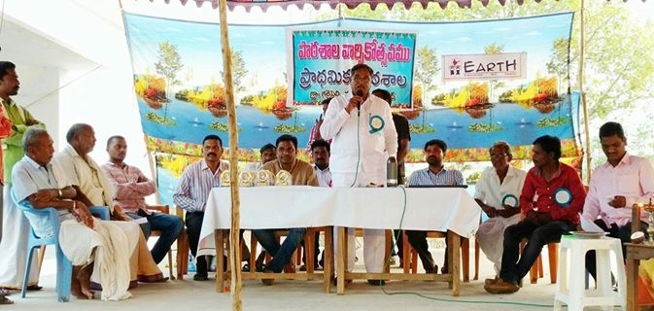 | 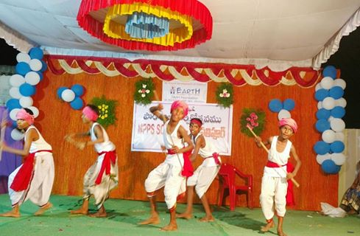

Press Coverge:

